ACCREDITATION FORM FOR TRAINING CENTRES

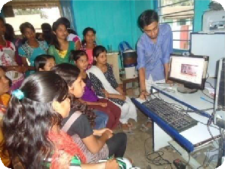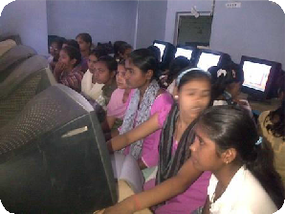

National Digital Literacy Mission

A collaborative approach to extend IT literacy to masses

BRIGHT FUTURE FOUNDATION TRUST
Regd. Office: J-1/406, Gali No-5,
Sangam Vihar New Delhi- 110080
Phone Number : 011 – 26041703 Mobile No: +917303131952
Email: bfft.delhi@gmail.com
Website: www.bimtindia.org

Approved By
Programme Management Unit – National Digital Literacy Mission CSC e-Governance Services India Limited
3rd Floor, Electronics Niketan, 6, CGO Complex Lodhi Road, New Delhi - 110003

Accreditation Form for Training Center

State : Delhi

District :

Block:

Panchayat:

Village:

- Name of the Training Centre: _______________________________________________________________
- Name of the Partner : Bright Future Foundation
- Name/s of the Centre Manager :
- Aadhar No : ________________________________ PAN No: _________________________
- Contact Details of the Centre:
- Postal Address:__________________________________________________________________________

_______________________________________________________________________________________________

_______________________________________________________________________________________________

- Phone No. with STD code: ____________________________________

- Fax No.:__________________________________________________

- Email and Mobile No. of the Centre Manager :________________________________________

_____________________________________________________

- Centre Manager Qualifications :
- No of computer at Centre :
- Internet Connectivity at Centre :
- Other IT Infrastructure at Centre :
- Power backup at Centre :
- Centre Area in Square Feet/Mts:
- Centre Picture :
- Bank Details:
Bank Name :
Bank A/C :
Branch Name :
IFSC Code :

I certify that, the foregoing information is correct and complete to the best of my knowledge and belief.
Signature

Programme Management Unit – National Digital Literacy Mission Page 2

14. Prior Exposure of the Training Partner in Education/ IT literacy (Enclose separate sheet, if required)

15. Year of Establishment: (Enclose Certificate of Registration)

16. 2. Turnover of the Training Center Rs……………………………..

List of documents to be attached:
1. Certificate of Registration for verifying year of establishment
2. Proof of prior exposure of the Training Centre in Education/ IT literacy
3. Photocopy of the PAN card and last IT return
4. Audited balance sheet of last 3 years

All Documents Please Sent To this Address

BRIGHT FUTURE FOUNDATION TRUST
Regd. Office: J-1/406, Gali No-5,
Sangam Vihar New Delhi- 110080
Phone Number : 011 – 26041703 Mobile No: +917303131952
Email: bfft.delhi@gmail.com
Website: www.bimtindia.org
http://bfftindia.mozello.com/ndlm/

